Brooklyn torah gazette
For rosh hashanah 5781
Volume 5, Issue 1 (Whole Number 202) 1 Tishrei 5781/ Sept. 19-20, 2020
Printed L’illuy nishmas Nechama bas R’ Noach, a”h

How an Annual Religious Pilgrimage Created a Year-Round Jewish Community in Uman, Ukraine
By Cnaan Lipshshiz

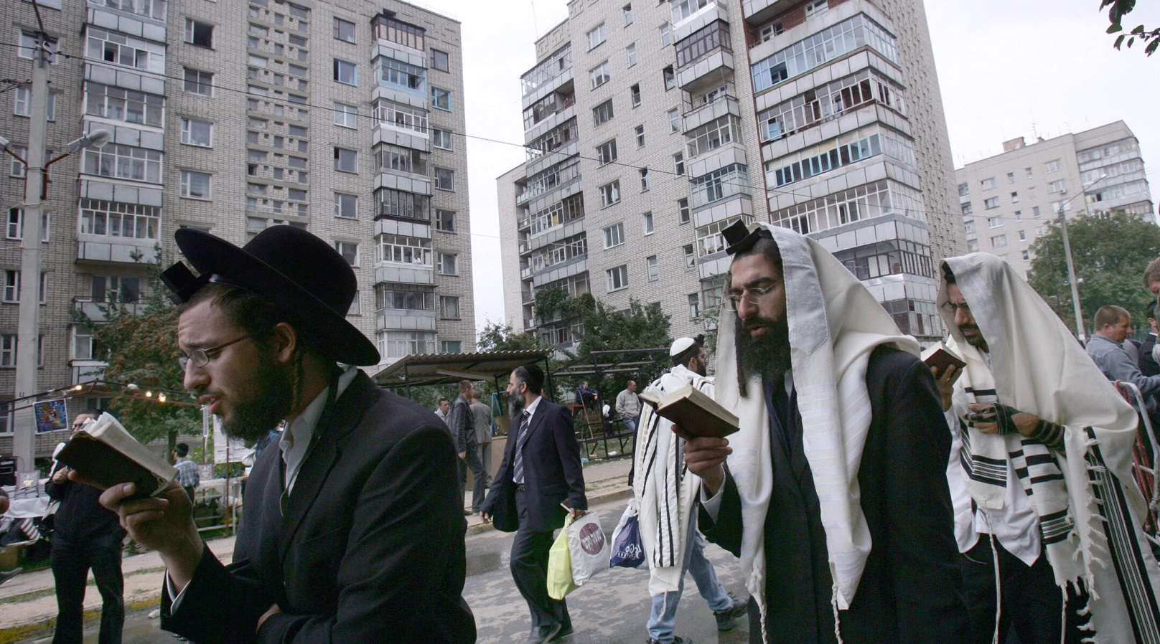
Jews pray on a street near the tomb of Rabbi Nachman of Breslov in Uman, Ukraine, Sept. 20, 2006. (Menahem Kahana/AFP via Getty Images)

(JTA) — Before deciding to stay permanently, Chaim Chazin would visit the small city of Uman, Ukraine, every year around Rosh Hashanah, the Jewish new year.
For Chazin, a religiously observant music producer from Israel, the brief annual visits were energizing spiritual experiences away from money troubles back home.
“There’s a feeling of holiness in Uman, of spirituality and of a return to the sources,” said Chazin, a father of seven. “It gives you the strength and inspiration to go on.”
Like tens of thousands of other observant Jews since the fall of communism in Europe, Chazin, 43, would come to this small city ahead of Rosh Hashanah because it’s the burial place of Rabbi Nachman, an 18th-century luminary who founded the Breslov Hasidic movement.

Prior to the Coronavirus, About 30,000
Jewish Pilgrims Would Come to Uman
Prior to Ukraine’s border shutdown due to the coronavirus, about 30,000 Jewish pilgrims, mostly from Israel, would come each year for the holiday. Many thousands more visit year round.
Chazin, his wife Liat and their children are among 70 families who have taken the Uman experience to a whole other level: They have moved there.
For most of the year, the city of 80,000 is sleepy and quiet. For Chazin, beyond the spiritual dimension of the place, he says “it’s easier to make a living here.”
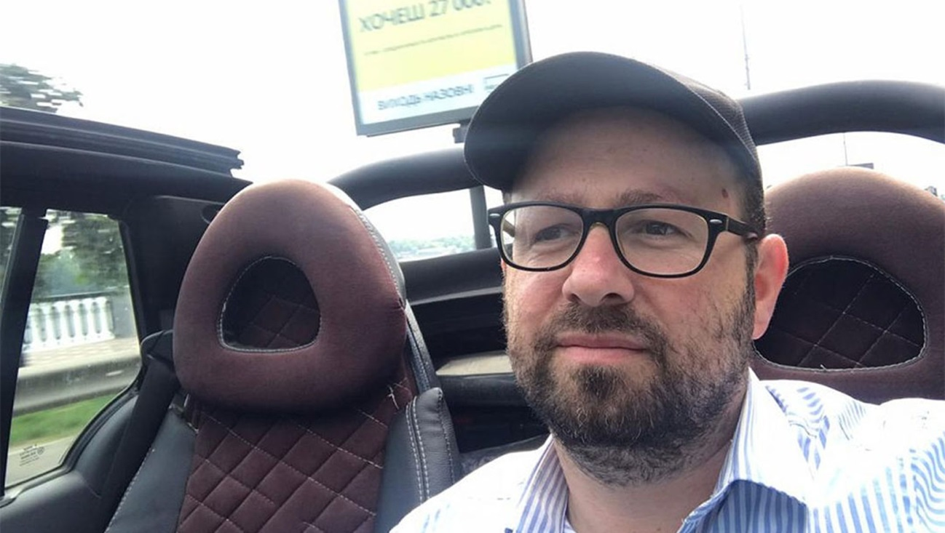
Chaim Chazin drives through Uman, Aug. 20, 2020. (Courtesy of Chazin)

“In Israel, I was always busy with bureaucracy, overdue payments, repossession notices, negotiating with the tax authorities. Ukraine is much easier in this regard. This is not a bureaucratic country,” he said.
Like many of the 200-odd Israeli observant Jews who live in Uman year-round, Chazin makes his living catering to the stream of Rosh Hashanah pilgrims. He owns real estate that he rents out to them and also has a hotel, in addition to other businesses.
The pilgrims are not big spenders. They typically part with only $50-$100 a day per person during their stays of four to seven days. But most of that money goes to relatively few service providers who either belong to, or are in business with, the permanent Jewish community of Uman. Whereas most pilgrims come for Rosh Hashanah, the thousands who visit year round provide a dependable source of income for the local Jews.

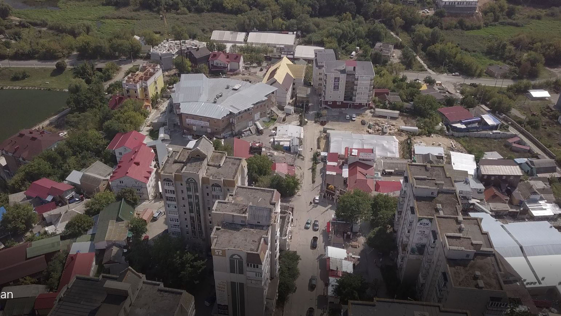
A bird’s eye view of Pushikna Street in Uman, Sept. 8, 2017. (Cnaan Liphshiz)

In a country where the average annual salary is about $6,000, this income, meager in Western terms, is enough for members of Uman’s permanent Jewish community to live comfortably and afford certain communal amenities enjoyed by few other Ukrainian Jewish communities of their size. They have a permanent rabbi from Israel, a mohel who performs circumcisions, and a kosher butcher. There’s a small elementary school for boys, another school for girls and even a Jewish kindergarten.
In terms of food, Uman’s Jews have an unusual amount of choice, thanks to the 10 or so kosher restaurants. Their existence means local Jews can order anything from Italian to Yemenite dishes. The community also has a grocery store with kosher meat and dairy products.

The Pilgrimage is Very Important to Breslover Chassidim
The pilgrimage is so important to some followers of the Breslov sect that about 1,500 of them rushed in to beat the border closure, which took effect on Aug. 29, and which some believe was imposed on that date to prevent the pilgrimage. Israeli and Ukrainian health officials have urged would-be pilgrims to stay away from Uman this year, warning it could become the epicenter for a new wave of cases.
The festival, as some call it, isn’t only Hasidic Jews — the group of festival-goers has included more secular Jews each year, some looking to party. Adding to the mix, leaders of the Breslov movement emphasize euphoria and joy rather than the intellectualism of other Orthodox Jewish streams. The result is, in the eyes of some observers, an enormous week-long Jewish party, complete with drugs, unsanitary accommodations and trash strewn in the streets.
Friction and an undercurrent of anti-Semitism has shadowed the presence of the many visibly Hasidic pilgrims in Uman for several years. Protests against the pilgrimage are not uncommon, nor are petitions and op-eds in the media. Some, including activists and supporters of the far-right Svoboda party, oppose it on racist grounds; others oppose it for practical reasons, saying it’s an unwelcome disturbance.
In some cases, the tensions play out in violent assaults. Brawls often break out between Jews and locals. Muggings are generally rare in Ukraine but occur regularly in Uman, where each year several pilgrims are violently relieved of their wallets, cell phones and other possessions. One such assault involving a robbery happened last week outside a local supermarket.

Several Acts of Anti-Semitic Vandalism
Several acts of anti-Semitic vandalism have occurred at one of the city’s several synagogues. In what was widely seen as a provocation, locals erected a large cross near a lake where pilgrims take ritual baths. In response, Jewish visitors vandalized it.
Rabbi Ya’akov Djan, a 46-year-old father of seven, took the community’s main rabbinical post about five years ago, moving to Uman with his wife and seven children. His family moved back to Israel in 2018 because one of his daughters needed special education.
“There are amenities, thank G-d, but life here is not easy,” Djan told the Jewish Telegraphic Agency. “We are not wanted here. There’s a lot of anti-Semitism, and lately because of the coronavirus, hospitals here are refusing to treat us. I’m worried about this.”
The involvement of the mafia and nepotism around the Jewish businesses of Uman — and the pilgrims’ at times rowdy behavior — does little to assuage the critics’ concerns.
Some hotels in Uman refuse to rent rooms to Jewish pilgrims, who have earned a bad reputation thanks to some who have started barbecue fires inside rented rooms, thrown trash out of windows or engaged in other forms of inconsiderate behavior.

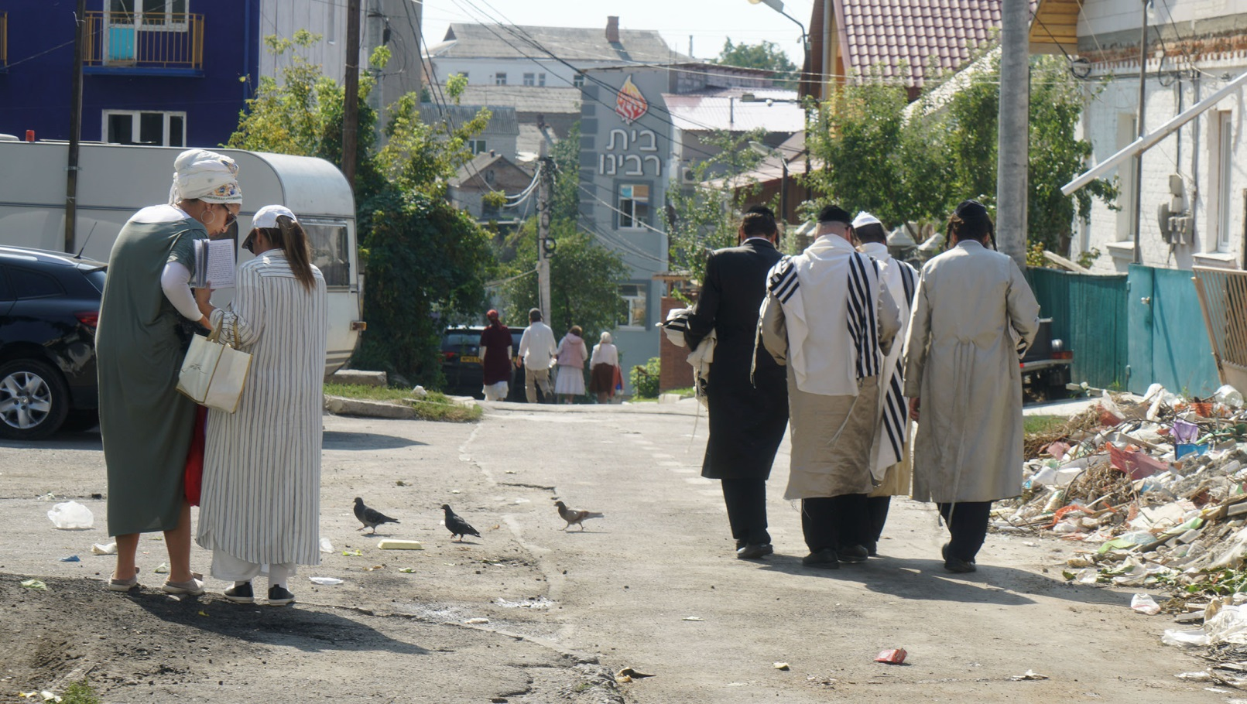
Jews walk down an alley leading to Pushkina Street in Uman, Sept. 8, 2017. (Cnaan Liphshiz)

But Chazin says the permanent Jewish community peacefully coexists with the rest of the city outside of the pilgrimage days. He added that tourist misbehavior used to be more common, but “is mostly a thing of the past, thanks to educational and outreach work” by spiritual leaders and local Jews.
One local, Shimon Buskila, told JTA in 2017 that some of the friction is “connected to misbehavior, abuse and violence by a certain fringe within the pilgrim community. Unfortunately, their actions can eclipse a record of coexistence which is mostly very positive.”
Chazin has a Ukrainian passport thanks to his parents, who were born there and immigrated to Israel decades ago. But most of Uman’s Jews have resident visas, which Ukraine gives anyone who can demonstrate they’ve made an investment of more than $100,000 in Ukrainian real estate or a business venture. A temporary staying permit can be obtained for much less.

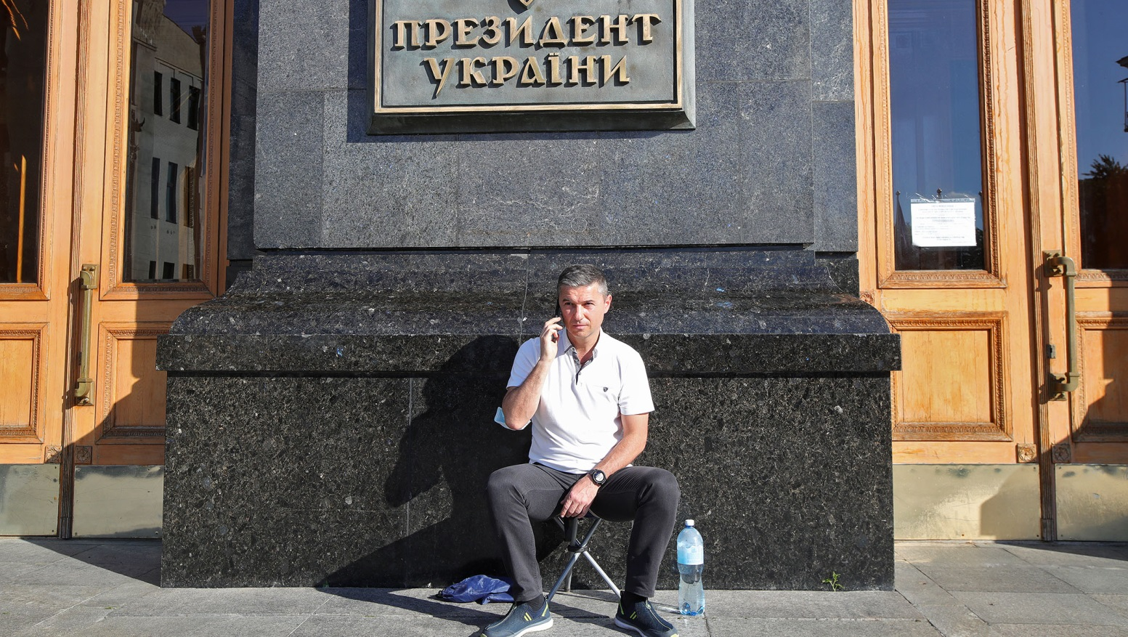
Oleksandr Tsebriy, the mayor of Uman, speaks on the phone outside the Cabinet of Ministers of Ukraine in Kyiv, Aug. 17, 2020. (Pavlo Bahmut/ Ukrinform/Barcroft Media via Getty Images)

Last month, Uman Mayor Oleksander Tsebriy complained in a filmed message on Facebook that Israelis are buying residence permits from corrupt immigration officials for $500, calling this a “form of fraud and manipulation that must stop.”
Tsebriy, a 46-year-old former car dealer who was elected to his post in 2015, is an outspoken critic of the pilgrimage, which he has placed at the center of his campaign for a second term in next month’s municipal elections. Amid fears that the pilgrims would be a health risk during the coronavirus pandemic, Tsebriy last month camped out outside the Kyiv office of Ukrainian President Volodymyr Zelensky, who is Jewish, demanding he ban the event.
A poll he conducted showed that “94% of Uman’s residents are against the traditional pilgrimage of Rosh Hashanah, though they have nothing against the pilgrims themselves,” Tsebriy told reporters outside Zelensky’s office.
According to his calculations, he said, the city’s annual revenue from the pilgrimage is only $270,000. Cleanup costs alone ate up more than a third of that income, in addition to extra water and maintenance costs.
The pilgrims aren’t the only tourists who come to Uman. Hundreds of thousands of people per year flock to Uman’s Sofiyivka Park, a 450-acre botanical garden that has been a symbol of creative arboreal design since it opened in the 19th century.
Chazin’s family are regulars at Sofiyivka, and on school vacations his wife, Liat, regularly takes the children to the beach in Odessa, a bustling metropolis with a vibrant Jewish scene that’s a three-hour drive away.
“In some important ways, the Uman community lives more comfortably than many other larger Jewish communities in Ukraine,” Chazin said.

Reprinted from the September 4, 2020 dispatch of the JTA (Jewish Telegraphic Agency).

Rosh Hashanah Cards
From the Holocaust
By Yad Vashem Photo Archives

A glimpse into some of the ways Jews before, during and immediately after the Holocaust marked the New Year. These images are part of a greater online exhibition on Yad Vashem's website.
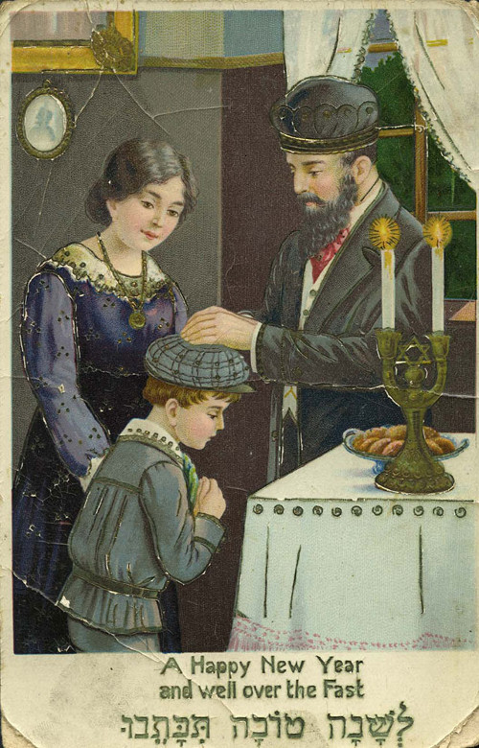
"Shana Tova" (Happy New Year) card sent to Henia Pollock in Argentina, from her relatives in Końskie, Poland, 1939
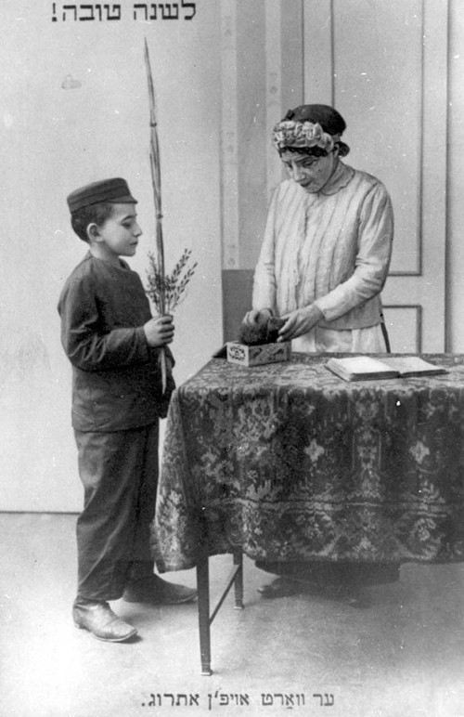
Prewar, Poland, a Rosh Hashanah greetings postcard, written in Yiddish
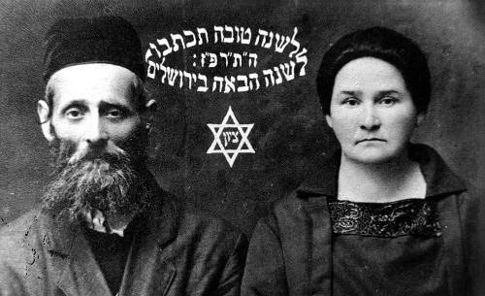
A Rosh Hashanah card sent by Aharon and Sheindl Blumen in 1926 from Luboml, Poland. The card reads: “May you be inscribed for a good year. Next year in Jerusalem.” The couple perished during the Holocaust.
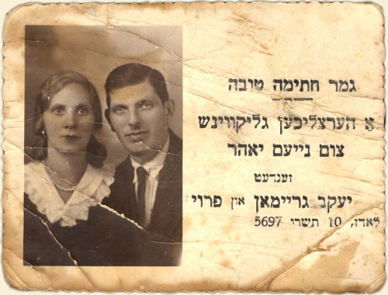
Jacob Graiman and his wife from Lodz, Poland on a New Year’s card, September 26, 1936. The couple perished during the Holocaust.
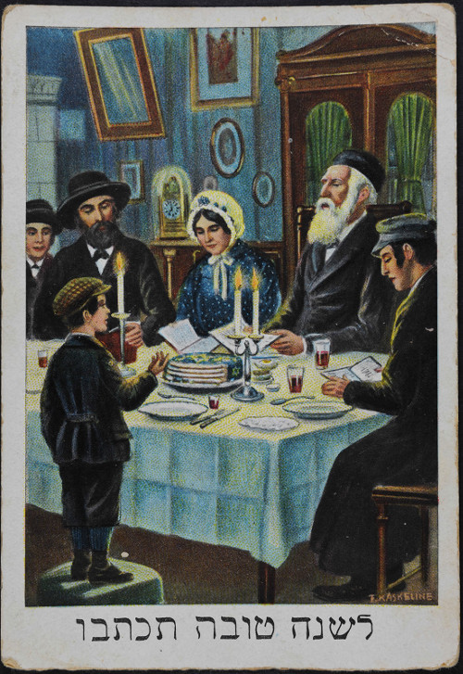
Postcard with greetings for the New Year that Miriam and Avraham-Simon Gorfinkel sent from Warsaw in the early 1930's to their son Schlomo and daughter-in-law Gitta who were living in Paris. "Your dear parents send to you and your wife, from deep in our hearts, wishes for a healthy and happy New Year, with prosperity and much joy."
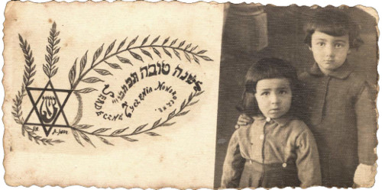
Druja, Poland, Meir Levitanus (the submitter) and his sister Chaya Miriam Marla, 1941
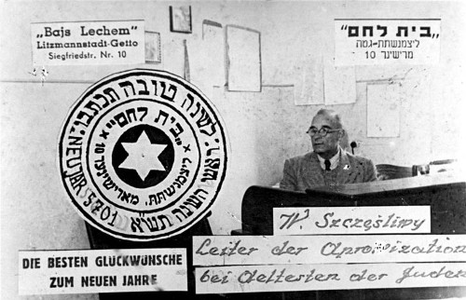
Lodz, Poland, a Rosh Hashanah greeting card, 1941. After the ghetto was closed in May 1940, a systematic array of services was installed. Among them, a food supply department whose officials began to apportion the meager provisions, and public kitchens and distribution points for bread and other staples were set up. This card apparently reflects one of those distribution points: Bajs Lechem (which appears in the upper left corner) means "House of Bread"

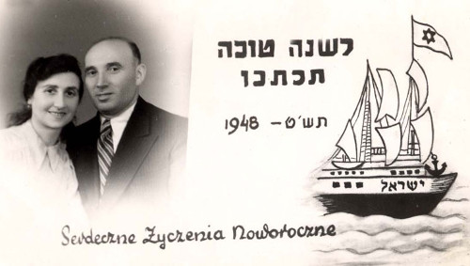
A New Year’s card sent by Yisrael Berman and his wife from Szczecin, Poland in 1948. The Hebrew inscription reads: “May you be inscribed for a good year.” The Hebrew on the boat reads: “Israel”.
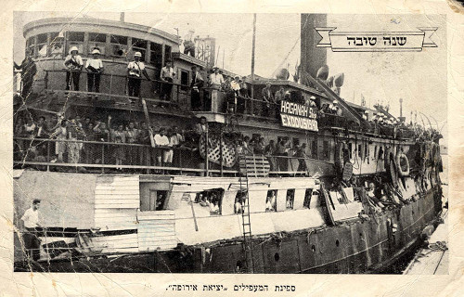
Pictured on this New Year’s card is the “illegal” immigration ship The Exodus 1947. The Exodus 1947 attempted to bring Jewish survivors to Palestine in 1947, only to be turned back to Europe by the British Mandate authorities and sent to Displaced Persons’ camps in Germany. The Exodus 1947 became an international symbol of the need for free Jewish immigration to Palestine. The refugees remained in the camps until 1948, when the State of Israel was established.
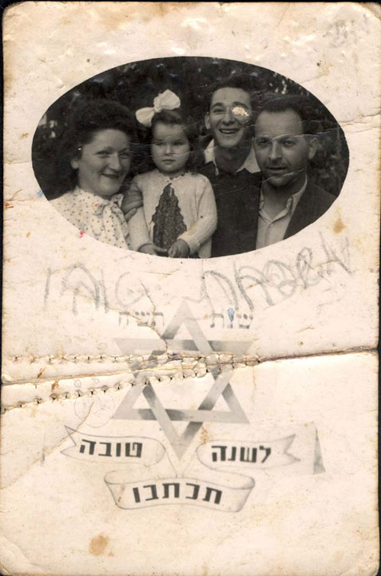
Lodz, Poland, a New Year greeting card, with the photo of the submitter's father's family.
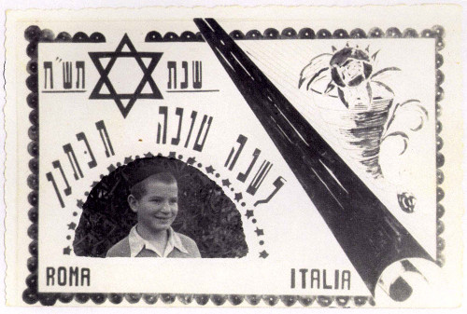
A New Year’s Card sent from the Meor HaGolah (Light of the Exile) Yeshiva in Rome in 1948. Many of the students of the yeshiva were Holocaust survivors. Pictured on the card is Israel Milkow, a student in the yeshiva from Slonim, Poland. During the Holocaust Israel was in a Russian orphanage in Samarkand, Uzbekistan.
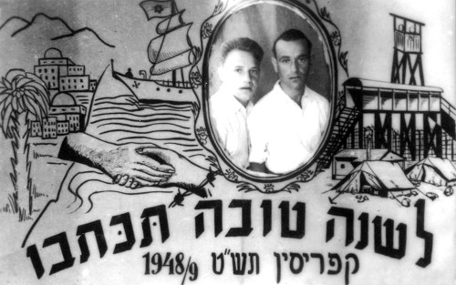
New Year greetings card, Cyprus, 1948. Sent by brothers David (right) and Yosef (left) Sin
Glossary for the Jewish New Year “Rosh Hashanah”
By Chabad.org Staff

Akedah: (lit. “the binding”); referring the Biblical account of The Binding of Isaac.
Aliyah: (lit. “ascent”); the honor of being called to recite the blessing upon the reading of the Torah scroll.
Aseret Yemei Teshuva: (lit, “the ten days of return”); the Days of Repentance, always the first ten days of the Jewish month of Tishrei, beginning on the Jewish New Year (Rosh Hashanah) and culminating on theDay of Atonement (Yom Kippur). A time period for focusing on prayer, charity and return to the G-dly path.
Arvit: the evening prayer service.
Avinu Malkeinu: (lit. “our Father, our King”); a prayer beseeching our Father in Heaven to grant us our needs, recited during prayer services throughout the High Holidays.
Baal Tokea: (lit. “master of the blast”); the person sounding the shofar ram’s horn in the synagogue.
Birchat Kohanim: (lit. “the blessing of the priests”); the blessings bestowed upon everyone in the Synagogue, on particular holidays, by the descendants of the priestly Biblical family of Aaron, known as the Kohanim (sin. Kohen).
Chag Sameach: (lit, “a happy festival”); one of the traditional holiday greetings.
Challah: (lit. “bread loaf”); a braided loaf baked in honor of theSabbath and major Jewish holidays.
D’vash: (lit. “honey”); traditionally eaten with challah bread and an apple on the Jewish New Year (Rosh Hashanah).
Eruv Tavshilin: (lit. “merging of cooked foods”); a procedure involving two prepared foods, that is performed on the eve of the holiday when a festival occurs on a Friday, to permit one to cook on the Friday for the Sabbath.
Gut Yom-Tov: (lit. “a good holiday”); one of the traditional holiday greetings.
Haftorah: (lit. “concluding portion”); a section from the Prophets read at the conclusion of the reading of the Torah scroll.
HaMotzi: (lit. “Who brings forth”); blessing recited over bread.
Hatarat Nedarim: the annulment of vows recited on the eve the Jewish New Year (alternatively it can be said earlier, or ten days later before the Day of Atonement).
Kara: (lit, “gourd”); one of the symbolic foods eaten on the evening of the Jewish New Year (Rosh Hashanah).
Karti: (lit. “leek”); one of the symbolic foods eaten on the evening of the Jewish New Year (Rosh Hashanah).
Ketiva vachatimah tovah: (lit. “may you be inscribed and sealed for a good year”); traditional greeting on the Jewish New Year (Rosh Hashanah).
Kezayit: (lit. “like an olive”); a measurement in Jewish law, formally described as the size of an olive, approximately one ounce or 25.6 grams.
Kiddush: (lit. “sanctification”); the blessings recited over a cup of wine at the onset of Sabbath and major Jewish Holiday meals, expressing the sanctity of the day.
Lekach: honey cake, traditionally eaten on the Jewish New Year (Rosh Hashanah). It is also traditional to request and receive a piece of honey cake on the eve of the Day of Atonement (Yom Kippur).
Leshanah tovah tikateiv veteichateim: (lit: “may you be inscribed and sealed for a good year”); traditional greeting on the Jewish New Year (Rosh Hashanah).
Maariv: the evening prayer services.
Machzor: (lit: "cycle"); the prayer book used on the Jewish New Year (Rosh Hashanah) and Day of Atonement (Yom Kippur).
Meren: (lit: "more" and alternatively "carrots"); a sweet carrot stew traditionally served during the Jewish New Year (Rosh Hashanah) meals.
Minchah: (lit. “the offering”); afternoon prayer service.
Musaf: “additional” prayer service recited on major Jewish holidays.
Pri chadash: (lit. “new fruit”) a seasonal fruit is eaten after the recitation of thekiddush on the second night of the Jewish New Year (Rosh Hashanah). The selected fruit should be one that one has not tasted since the beginning of the season.
Rosh dag: (lit. “head of a fish”); the head of a fish, ram, or other kosher animal is served on the Jewish New Year (Rosh Hashanah).
Rimon: (lit. “pomegranate”); a pomegranate is traditionally eaten on the night of the Jewish New Year (Rosh Hashanah).
Rosh Hashanah: (lit. “head of the year”); the holiday marking the Jewish New Year, always occurring on the first two days of the Jewish month of Tishrei; beginning the ten Days of Repentance (Aseret Yemei Teshuva).
Rosh keves: (lit. “ram’s head”); the head of an ram that some traditionally serve on the night of the Jewish New Year (Rosh Hashanah).
Rubia (Lubia): small beans that some traditionally serve on the night of the Jewish New Year (Rosh Hashanah).
Salka: beets that some traditionally serve on the night of the Jewish New Year (Rosh Hashanah).
Selichot: penitential prayers read daily before dawn during the week preceding the Jewish New Year (Rosh Hashanah).
Shabbat Selichot: The Sabbath preceding the Jewish New Year (Rosh Hashanah). The following morning begins the recitation of selichot penitential prayers.
Shacharit: (lit. “the dawning”); the morning prayer service.
Shana tovah: (lit. “good year”) traditional greeting during the Jewish month of Elul and on the Jewish New Year (Rosh Hashanah).
Shofar: A ram’s horn blown daily during the Jewish month of Elul (not including the last day), on the Jewish New Year (Rosh HaShanah), and at the end of the Day of Atonement (Yom Kippur).
Shevarim: the three shofar ram’s horn blasts of intermediate length.
Shofrot: (a) plural for the shofar (ram's horn); (b) one of the blessings in the musaf prayer service of the Jewish New Year (Rosh HaShanah), consisting of verses reflecting the importance of sounding the shofar.
Tapuach bidvash: a piece of apple dipped into honey traditionally served on the night of the Jewish New Year (Rosh Hashanah).
Tachanun: (lit. “supplication”); the penitential prayers recited on all non-festive days.
Tashlich: (lit. “You shall cast”); the riverside ritual of casting one’s sins into the waters on the Jewish New Year (Rosh HaShanah).
Tekiah: the protracted Shofar blast.
Tekiah Shevarim Teruah Tekiah: the traditional order of the sounds of the shofar: a long steady blast, a series of medium-length wailing blasts, a series of very short sounds in rapid succession, followed by another long steady blast.
Temarim: dates that some traditionally serve on the night of the Jewish New Year (Rosh Hashanah).
Teruah: the staccato Shofar blast.
Teshuvah: (lit. “return”); repentance, the return to the correct path of observance of G-d’s commandments.
Tzedakah: (lit. “justice, righteousness”); charity, traditionally given in abundance prior to the Jewish New Year (Rosh Hashanah).
Tzimmes: a sweet carrot stew traditionally served during the Jewish New Year (Rosh Hashanah) meals.
Unetaneh Tokef: (lit: “let us relate the power”); one of the powerful prayers recited during the High Holidays.

Reprinted from the Erev Rosh Hashanah 5777 email of Chabad.Org Magazine.

How Do You Wish Someone Happy Rosh Hashanah?
By Katie Whitfield

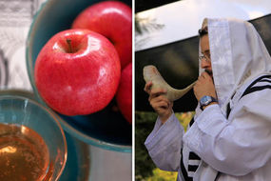
On Rosh Hashanah there is a custom to dip apples into honey and to blow the shofar

Rosh Hashanah is one of the most important dates in the Jewish calendar.
The date marks the first of the High Holidays, a ten-day period which ends with Yom Kippur, the holiest day of the Jewish year.
On Rosh Hashanah, Jews all around the globe celebrate the creation of the world and have an opportunity to ask for forgiveness and start afresh.
Rosh Hashanah is two days long and usually occurs during the months of September, this year beginning on the evening of Sunday, September 9, and ending on the evening of Tuesday, September 11.
Rosh Hashanah is the birthday of the universe in Jewish belief, the day G-d created Adam and Eve.
The celebration begins at sundown on the eve of Tishrei 1 - the Hebrew month corresponding with September/October.
Directly translated, Rosh Hashanah means ‘head of the year’.
How do you wish someone happy Rosh Hashanah?
There are a few ways to wish your Jewish friends a happy new year.
Saying ‘Shana Tova’, which means ‘For a good year’ in Hebrew, is the most common greeting.

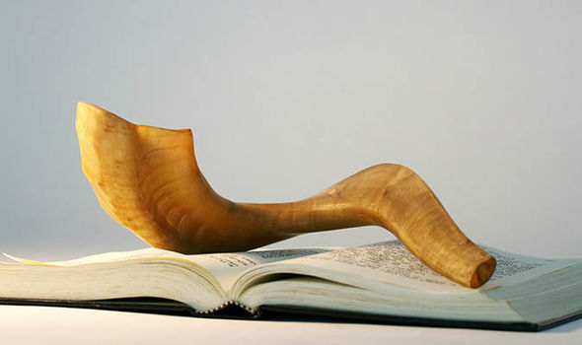
A shofar atop a Machzor, a special prayer book for Rosh Hashanah

If you want to express the same sentiment but more elaborately, you can say ‘Shanah Tovah Umetukah’, which means ‘A good and sweet year’.
And a Rosh Hashanah greeting used by the devout is ‘L’Shanah Tovah Tikatevu V'taihatem’, which means ‘May you be inscribed and sealed for a good year’.

How is Rosh Hashanah celebrated?
During Rosh Hashanah, Jewish people ask G-d for forgiveness for anything they may have done wrong the previous year.
The holiday is an opportunity to remind oneself not to repeat the mistakes again in the year ahead.
Rosh Hashanah is also seen as an annual observation of improvement and fresh starts.
Jews from all over the world celebrate Rosh Hashanah, and traditions can vary depending on the region.
Candle lighting in the evenings, festive meals and prayer services on both mornings are fundamental parts of the holiday.
A special prayer service is held at a synagogue, and the shofar - a horn from a ram - is blown.
Charitable giving, known as Tzedakah, is also an important part of the holiday.
Jews are expected to desist from creative work during Rosh Hashanah.

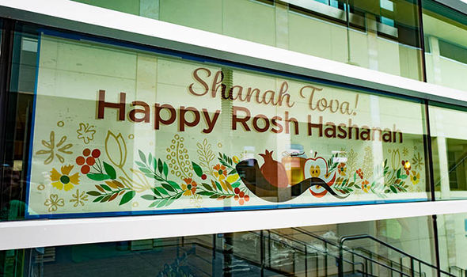

Food is a crucial element of Rosh Hashanah, including many special meals.
Meals begin with reciting the kiddush prayer over wine, and then a blessing over bread.
Sweet food is eaten to symbolise hope for a sweet year ahead.
Some other foods commonly enjoyed are pomegranates, apples in honey, challah bread, and fish.
Nuts, vinegar, horseradish and other sharp or bitter foods are avoided to prevent a bitter year.

Reprinted from the September 10, 2018 edition of the Daily Express (U.K.)

